

**Microfocus Server Automation Agent Installation**

# **Document Control**

## **Author**

Document Author: Irshad Khan

## **Version Control**

|  |  |  |  |
| --- | --- | --- | --- |
| **Version** | **Date** | **Editor** | **Changes / Comments** |
| 1.0 | 06/12/2019 | Ishant Walia | First Draft |
| 1.1 | 06/12/2019 | Irshad Khan | Changed formatting |
| 1.2 | 06/12/2019 | Irshad Khan | Updated Satellite servers’ details |
| 1.3 | 19/05/2020 | Harish Sivadasan | Modified Satellite servers’ details |

## **Procedural tests**

|  |  |  |  |
| --- | --- | --- | --- |
| **Version** | **Date** | **Test Conductor** | **Result** |
|  |  |  |  |
|  |  |  |  |
|  |  |  |  |

## **Contributors**

|  |  |
| --- | --- |
| **Version** | **Contributor** |
|  |  |
|  |  |
|  |  |

# **Document scope and limitations**

This document outlines the standard operating procedure for Microfocus Server Automation Agent installation procedure.

This document applies to the pre/Prod environment Microfocus Operation Orchestration software.

# **Definition of terms and acronyms**

|  |  |
| --- | --- |
| **Term/ Acronym** | **Definition** |
| SA | Server Automation |
| MF | Microfocus |

**Contents**

[**Document Control** 2](#_Toc31629761)

[**Author** 2](#_Toc31629762)

[**Version Control** 2](#_Toc31629763)

[**Procedural tests** 2](#_Toc31629764)

[**Contributors** 2](#_Toc31629765)

[**Document scope and limitations** 3](#_Toc31629766)

[**Definition of terms and acronyms** 4](#_Toc31629767)

[**Prerequisites:** 6](#_Toc31629768)

[**Disk Space requirement:** 6](#_Toc31629769)

[**Permissions & port:** 6](#_Toc31629770)

[**Windows Server Installation:** 6](#_Toc31629771)

[**Linux Server Installation:** 7](#_Toc31629772)

[**How to check OS** 7](#_Toc31629773)

[**Troubleshooting Agent issue** 9](#_Toc31629774)

[**Uninstall agent:** 9](#_Toc31629775)

[**For Linux:** 9](#_Toc31629776)

[**For Windows:** 9](#_Toc31629777)

[**Re Install agent using below command:** 9](#_Toc31629778)

# **Prerequisites:**

# **Disk Space requirement:**

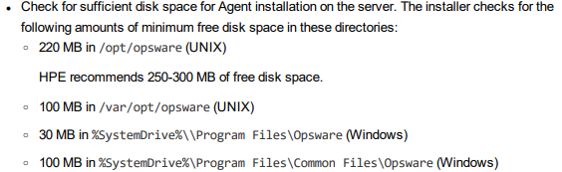

# **Permissions & port:**

* Admin$, C$ access for windows servers (TCP 445,135).
* Root/ Sudo account for Linux
* SSH access for Linux servers (TCP 22).
* Port Needs to be open for Agent installation/communication:

TCP 1002, TCP 3001 bidirectional. (Target m/c to SA application server)

# 

# **Windows Server Installation:**

Place the installation agent media on target machine.

For windows there are 3 setups aligned for different versions of windows.

Detail are mentioned below:

|  |  |  |
| --- | --- | --- |
| **Sr. No** | **Installation Media Name** | **OS Version** |
| 1 | opsware-agent-75.0.79005.0-win32-6.1-X64 | Windows Server 2008 R2 |
| 2 | opsware-agent-75.0.79005.0-win32-6.2-X64 | Windows Server 2012 |
| 3 | opsware-agent-75.0.79005.0-win32-6.3-X64 | Windows Server 2016 |

**Note: Check for the Area near your server and replace the value for parameter –opsw\_gw\_addr accordingly**

**For Servers in Cape Town location Use: pdca106zafsrh.vodacom.corp:3001 or pdca108zafsrh.vodacom.corp:3001**

**For Servers in Johannesburg location Use: pdca101zadprh.vodacom.corp:3001 or pdca102zadprh.vodacom.corp:3001**

**For Servers in Vodacom Engineering location Use: cte-vm-dcasat01:3001**

**For Servers in Vodacom ECS location Use: pdcaecs01zatcrh:3001**

**For Servers in Vodacom PVA (Project Vision App) location Use: pvap001aa11rh:3001**

Once Media is copied run below command to install agent.

E.g.: For this binary “opsware-agent-75.0.79005.0-win32-6.1-X64”

**\path-to-the-file\opsware-agent-75.0.79005.0-win32-6.1-X64.exe --opsw\_gw\_addr <Gateway server hostname according to your server location>:3001**

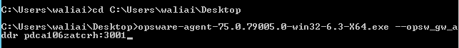

# **Linux Server Installation:**

Place the installation agent media on target machine. (Let’s say in tmp directory)

Make the file executable:    [chmod +x /tmp/opsware-agent\*](http://elppadm01.nc.checkfree.com/pub/opsware-agent-37.0.0.2.84-linux-5SERVER-X86_64" \t "_blank)



For Linux there are 3 setups aligned for different versions of OS.

Detail are mentioned below:

|  |  |  |
| --- | --- | --- |
| **Sr. No** | **Installation Media Name** | **OS Version** |
| 1 | opsware-agent-75.0.79005.0-linux-5SERVER-X86\_64 | RHEL 5 |
| 2 | opsware-agent-75.0.79005.0-linux-6SERVER-X86\_64 | RHEL 6 |
| 3 | opsware-agent-75.0.79005.0-linux-7SERVER-X86\_64 | RHEL 7 |

|  |  |  |
| --- | --- | --- |
| **Sr. No** | **Installation Media Name** | **OS Version** |
| 1 | opsware-agent-75.0.85351.0-linux-CENTOS5-X86\_64 | CENTOS 5 |
| 2 | opsware-agent-75.0.85351.0-linux-CENTOS6-X86\_64 | CENTOS 6 |
| 3 | opsware-agent-75.0.85351.0-linux-CENTOS7-X86\_64 | CENTOS 7 |

According to OS choose the binaries:

# **How to check OS**

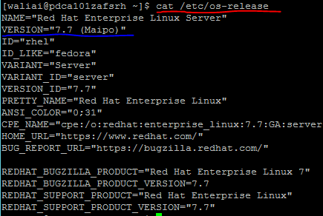

Once Media is copied run below command to install agent.

**E.g.:** For this binary “opsware-agent-75.0.79005.0-linux-7SERVER-X86\_64”

**./opsware-agent-75.0.79005.0-linux-7SERVER-X86\_64 --opsw\_gw\_addr <Gateway server hostname according to your server location>:3001**



**Note: Check for the Area near your server and replace the value for parameter –opsw\_gw\_addr accordingly**

**For Servers in Cape Town location Use: pdca106zafsrh.vodacom.corp:3001 or pdca108zafsrh.vodacom.corp:3001**

**For Servers in Johannesburg location Use: pdca101zadprh.vodacom.corp:3001 or pdca102zadprh.vodacom.corp:3001**

**For Servers in Vodacom Engineering location Use: cte-vm-dcasat01:3001**

**For Servers in Vodacom ECS location Use: pdcaecs01zatcrh:3001**

**For Servers in Vodacom PVA (Project Vision App) location Use: pvap001aa11rh:3001**

I**f the above commands didn’t work and agent installation failed/ agent not started or not reflecting in SA client console?**

Follow below process:

Start the agent manually:

For Linux: **/etc/init.d/opsware-agent start/stop**

For Windows: **net start/stop opswareagent**

# **Troubleshooting Agent issue**

If Agent services not started on node or if it is not able to communicate with SA Core server.

Perform following tasks.

# **Uninstall agent:**

# **For Linux:**

/opt/opsware/agent/bin/agent\_uninstall.sh

# **For Windows:**

Go to Control agent> uninstall> HP SA Agent



# **Re Install agent using below command:**

**./opsware-agent-75.0.80746.0-linux-6SERVER-X86\_64 --logfile agent.log --loglevel info --opsw\_gw\_addr <Gateway server hostname according to your server location>:3001 --force\_full\_hw\_reg --force\_sw\_reg --auth\_path /full/path/to/agent.srv**

**./opsware-agent-75.0.80746.0-linux-6SERVER-X86\_64 (**SA agent binary file**)**

**/full/path/to/agent.srv (**copy the certificate agent.srv frombelow path, and place it in above command)

**Certificate path:** [\\10.132.88.233\p$\SA\_client\_certificate](file://10.132.88.233/p$/SA_client_certificate)

After finishing the Installation please inform to DCA patch management team to validate the communication with SA Core Server.

In case of any queries please contact to DCA team.